

**Social network**

**Software Requirement Specification**

– DaNang, 2022 –

**Table of Contents**

I. Overview 3

1. Introduction 3

2. System Functions 4

3. Common Requirements 5

II. Functional Requirements 6

1. <<Feature Name 1>> 6

a. <<Function Name 1>> 6

b. <<Function Name 2>> 6

2. <<Feature Name 2>> 6

# I. Overview

## 1. Introduction

*Since ancient times, we humans have always wanted to explore the world, the universe or the sea, or closer things, each person’s experience of something.*

*In the past, when science and technology were not as developed and modern as today, people stored those experiences in books, or by word of mouth. And if you want to share those stories and experiences, you have to meet the people who experience them directly or read their diaries.*

*And today, with development, people have more and more conditions to discover and experience, so the storage or sharing of stories becomes diverse and rich.*

*Realizing the trend of the times, people need a place to directly share their feelings and excitement about their own experiences, so [Tên ứng dụng] will be a great platform to help people connect with each other to share great stories about each person’s life and experiences*

*[Tên ứng dụng] is a web application that will give users a space to help people connect with each other. A place where people share their own stories with friends and family, a place where you can communicate with friends, it's a social network that connects people.*

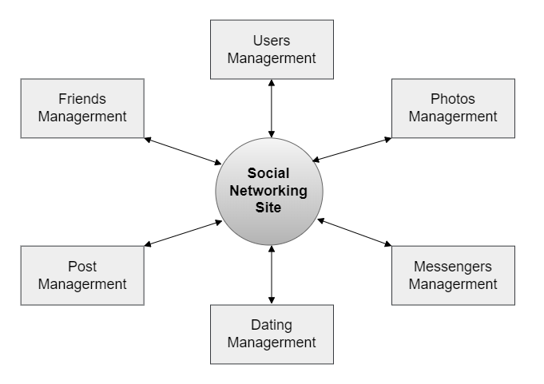

Use Case:

Figure 1.0: Use case diagram of [Name]

## 2. System Functions

#### a. Screen Flow

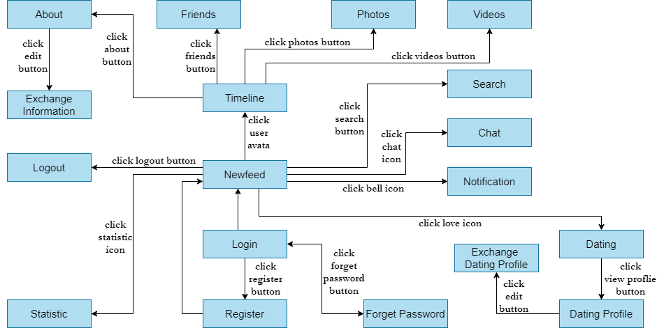

#### b. Screen Details

|  |  |  |  |
| --- | --- | --- | --- |
| **#** | **Feature** | **Screen** | **Description** |
| 1 | Log in | Login | Enter user account to access the site. |
| 2 | Register | Register | Register a new account. |
| 3 | Reset password | Forget Password | Reset the password of user account. |
| 4 | View new feed | Newfeed | View all friend’s post at this page. |
| 5 | View user profile | Timeline | View user’s post. |
| 6 | View user information | About | View user’s information. |
| 7 | Exchange Information | Exchange Information | Exchange user’s information (avata, name, phone, …). |
| 8 | View list friend | Friends | View user’s list friend. |
| 9 | View photo | Photos | View user’s photos. |
| 10 | View video | Videos | View user’s videos. |
| 11 | Search others | Search | Search others user. |
| 12 | Chat | Chat | Chat with others. |
| 13 | View notification | Notification | View notifications. |
| 14 | Statistic | Statistic | Admin view all kinds of website statistics. |
| 15 | View list post is reported | Reported | Admin view list post is reported. |
| 16 | Dating | Dating | Looking for someone to match. |
| 17 | View dating profile | Dating Profile | View user’s dating information. |
| 18 | Exchange Dating Profile | Exchange Dating Profile | Exchange user’s dating information. |
| 19 | Log out | Logout | Log out of the site. |

#### c. User Authorization

|  |  |  |  |
| --- | --- | --- | --- |
| **Screen** | **User** | **Admin** | **Not User** |
| << Login>> | X | X | X |
| Manual login | X | X |  |
| << Register >> | X | X | X |
| Manual register | X | X | X |
| << Forget Password >> | X | X | X |
| Reset password | X | X |  |
| << Newfeed >> | X | X |  |
| View new post | X | X |  |
| Comment post | X | X |  |
| Like post | X | X |  |
| Report post | X | X |  |
| Delete comment | X | X |  |
| Dislike post | X | X |  |
| << Timeline >> | X | X |  |
| Upload post | X | X |  |
| Delete post | X | X |  |
| View post | X | X |  |
| Comment post | X | X |  |
| Like post | X | X |  |
| Report post | X | X |  |
| Send friend request | X | X |  |
| << About >> | X | X |  |
| View user’s information | X | X |  |
| << Exchange Information >> | X | X |  |
| Edit information | X | X |  |
| << Friends >> | X | X |  |
| View user’s friends | X | X |  |
| << Photos >> | X | X |  |
| View user’s photos | X | X |  |
| << Search >> | X | X |  |
| Search others by name | X | X |  |
| << Chat >> | X | X |  |
| Chat with others | X | X |  |
| << Notification >> | X | X |  |
| View notifications | X | X |  |
| << Statistic >> |  | X |  |
| View statistics |  | X |  |
| << Reported >> |  | X |  |
| View list post is reported |  | X |  |
| Block user is reported |  | X |  |
| Delete user is reported |  | X |  |
| << Dating >> | X | X |  |
| Looking for someone | X | X |  |
| Like someone | X | X |  |
| Hide someone | X | X |  |
| << Dating Profile >> | X | X |  |
| View profile | X | X |  |
| << Exchange Dating Profile >> | X | X |  |
| Edit information | X | X |  |
| << Logout >> | X | X |  |
| Logout | X | X |  |

In which:

* User: The person who are using the Social Networking Site.
* Admin: The person who are managing the Social Networking Site.
* Not user: The person who do not have account.

#### d. Non-Screen Functions

|  |  |  |  |
| --- | --- | --- | --- |
| **#** | **Feature** | **System Function** | **Description** |
| 1 | Login with Google account | Google API | Allow user login to Social Networking Site by their Google account. |
| 2 | … |  |  |

## 3. Common Requirements

*Language:*

* *Java*
* *SQL*
* *JS*

# II. Functional Requirements

## 1. <<Account Operation>>

### a. <<Register>>

- Function trigger: Click on the Register button on the Home Page

- Function description: If you don’t have an account, you need to register new account to use Social Network Site.

- Screen layout: 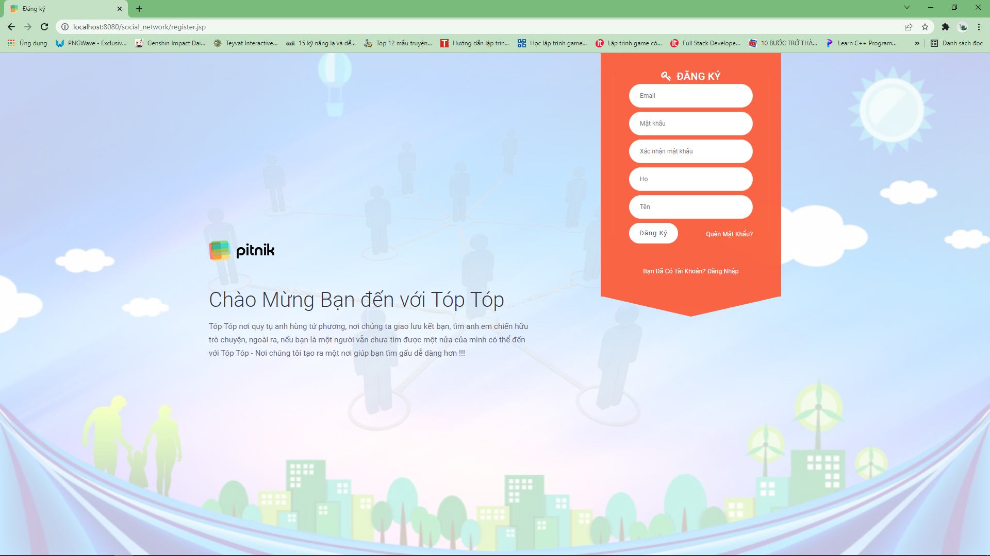

- Function Details: Confirm some of this information: Compare Username and Email to the data in the DB to check if it is not existed, Compare The Password and Confirm password if it’s matched. If no error occurs, register the new account into the Database.

### b. <<Login>>

- Function trigger: Click on the Login button on the Home Page. Or user can login by click on the *Login by Google* button to login by their google account.

- Function description: If you want to use Social Network Site, you need to login to your account.

- Screen layout: 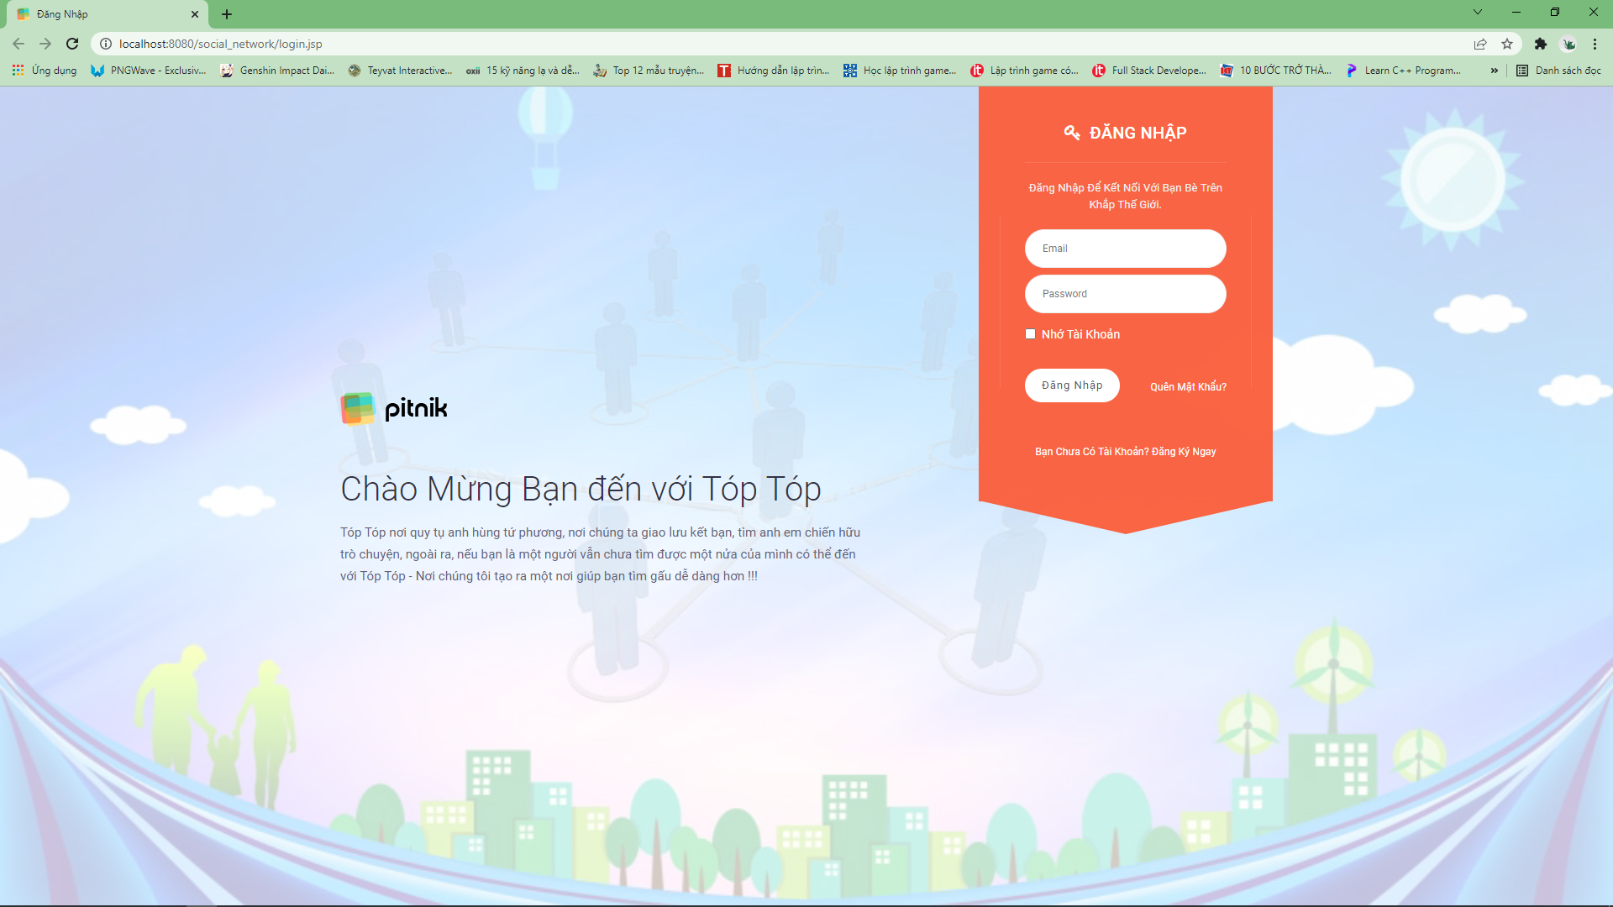

- Function Details: Compare Username and Password to the Username and Password created in the database, if it’s matched then login. But if it doesn't, deny access.

## 2. Posts Operation

### a. <<Add Posts>>

- Function trigger: On their timeline, click on the Post button.

- Function description: You need to login to your account to create new post.

- Screen layout:

- Function Details: When user click on the Post button, the system add the data to the Database and also display this new post on new feed.

### b. <<Edit Posts>>

- Function trigger: On user’s timeline, click Edit icon of the post.

- Function description: You need to login to your account to edit your post, user can edit their post only.

- Screen layout:

- Function Details: Allow user to edit information of the post.

### c. <<Delete Posts>>

- Function trigger: On user’s timeline, click Delete icon of the post.

- Function description: You need to login to your account to delete your post, admin can delete the post of all users, user can delete their post only.

- Screen layout:

- Function Details: Allow user to delete their post.

## 3. Chating Operation

### a. <<Message>>

- Function trigger: Click on the chat icon to show the message box.

- Function description: User can send message with the other users.

- Screen layout:

## 3. User operation

### a. <<Comment on Posts>>

- Function trigger: On the post, click on the Comment icon. A box will show below the post, user can comment on it.

- Function description: User need to login to their account. User can comment on the posts display on their feed.

- Screen layout:

- Function Details: When user press Enter, the system add the comment into the Database.

### c. <<Dating>>

- Function trigger: Click on the Dating icon.

- Function description: Users can find the match person for them.

- Screen layout: 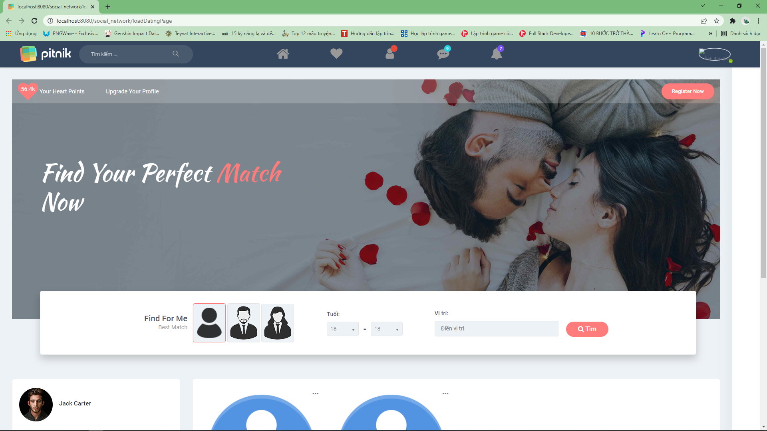

- Function Details: When user press Enter, the system add the comment into the Database.